**Bangladesh University of Business and Technology**

**(BUBT)**



**Project Proposal**

Project Name : Blood Bank Management System

Course Title : Database System Lab

Course Code : CSE 208

Submitted To:

Farha Akter Munmun

Assistant Professor

Department of CSE

Bangladesh University of Business and Technology (BUBT)

|  |  |  |  |
| --- | --- | --- | --- |
| **Submitted By** | | | |
|  |  |  |  |
| Name | ID | Intake | Section |
| Md. Mehedi Hasan | 21225103334 | 49 | 08 |
| Mushfiqur Rahman Pulok | 21225103525 | 49 | 08 |
| Abdullah Al Hill Baki Anim | 21225103341 | 49 | 08 |
| Faiza Khandoker Fama | 21225103338 | 49 | 08 |
| Jannatul Ferdous | 21225103350 | 49 | 08 |

|  |
| --- |
| **Objective** |

The main objective of this project is to create a desktop-based application that can store information about its users and the donors of the blood bank, also store blood bags and update the details of its inventory.

|  |
| --- |
| **Project idea** |

Currently, dengue has become an epidemic in Bangladesh. Due to this many people are suffering from anemia and platelet deficiency. Finding the necessary blood has become difficult. People often post online or message their group for necessary blood but it doesn’t help them much. Some organizations even maintain a list of donors and their details but often they are not updated. It is one of the major reasons why we have decided to make a blood bank management system. Our purpose is to make an application where admins can add or remove details of donors and admin or users can login to update their details. In this way we can help patients with safe blood supply when they are needed.

|  |
| --- |
| **Features** |

The key features of this project are:

* **Login**: Users/admins can login to their accounts.
* **Update user details**: Admins can update their information of their accounts.
* **Update donor details**: Admins can add and update the donor’s information.
* **Dashboard**: Number of donors of each blood group is shown.
* **Inventory**: Number of bags of each blood group is shown. The numbers are updated when new supply of blood comes in the blood bank or blood is donated to someone from the bank.

|  |
| --- |
| **Schema Definition & Diagram** |

*tbl_users (user_id, username, email, password, full_name, contact, address, added_date)*

*tbl_donors (donor_id, first_name, last_name, email, contact, gender, address, blood_group, added_date, added_by)*

*stock (bd_id, blood_group, quantity)*

|  |  |  |  |  |  |  |  |  |  |  |  |  |  |  |  |  |  |  |  |  |  |  |  |  |  |  |  |
| --- | --- | --- | --- | --- | --- | --- | --- | --- | --- | --- | --- | --- | --- | --- | --- | --- | --- | --- | --- | --- | --- | --- | --- | --- | --- | --- | --- |
| |  | | --- | | **tbl_users** | | user_id | | username | | email | | password | | full_name | | contact | | address | | added_date | | |  | | --- | | **tbl_donors** | | donor_id | | first_name | | last_name | | email | | contact | | gender | | address | | blood_group | | added_date | | added_by | | sonation_date | | |  | | --- | | **stock** | | bd_id | | blood_group | | quantity | |

**Fig: schema diagram.**

1. Loading interface

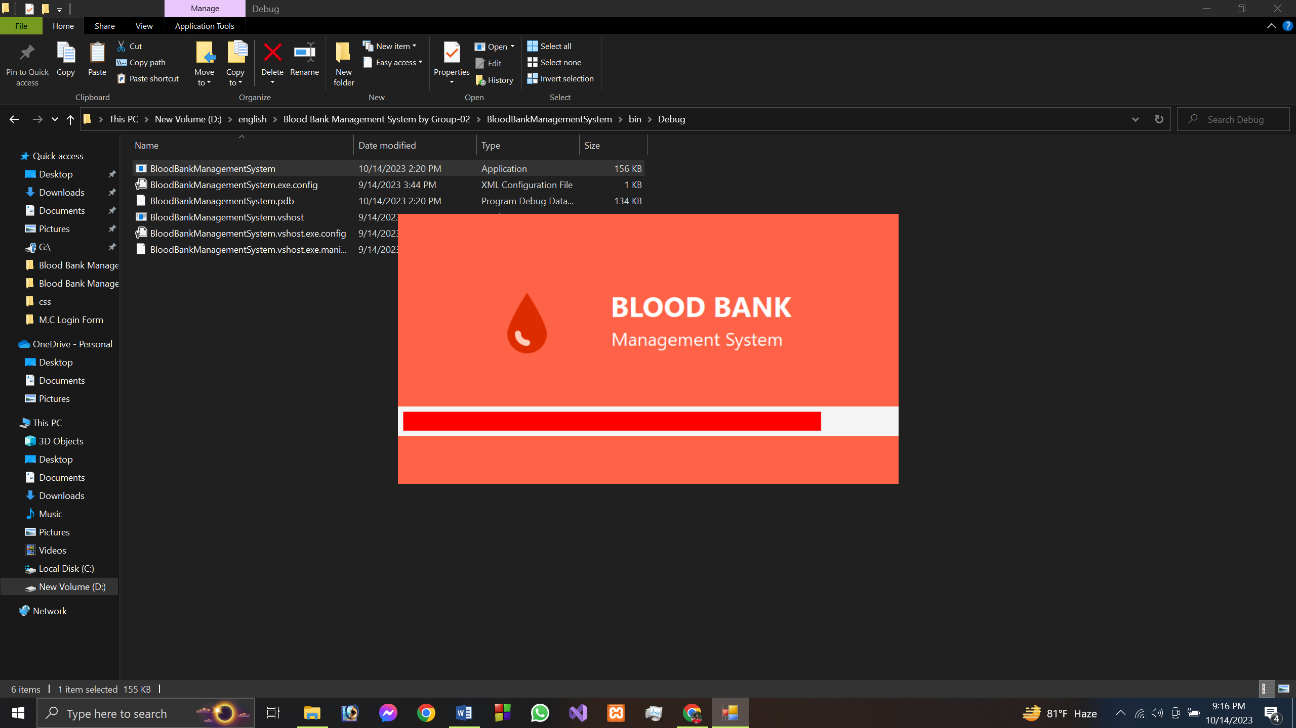

2.Login panel

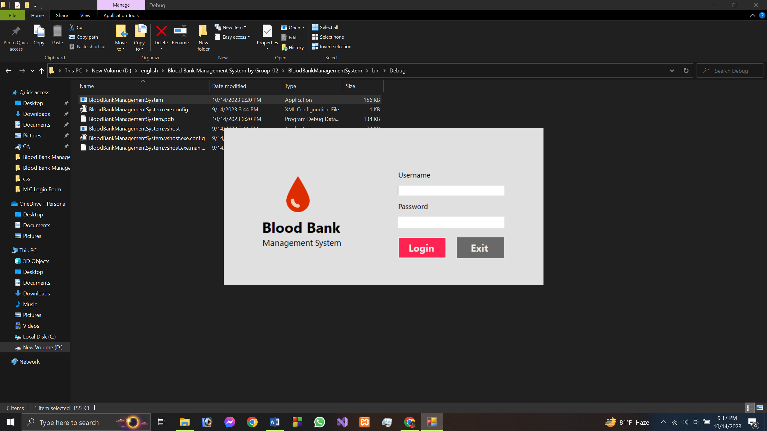

3.Succesfully login shows welcome message

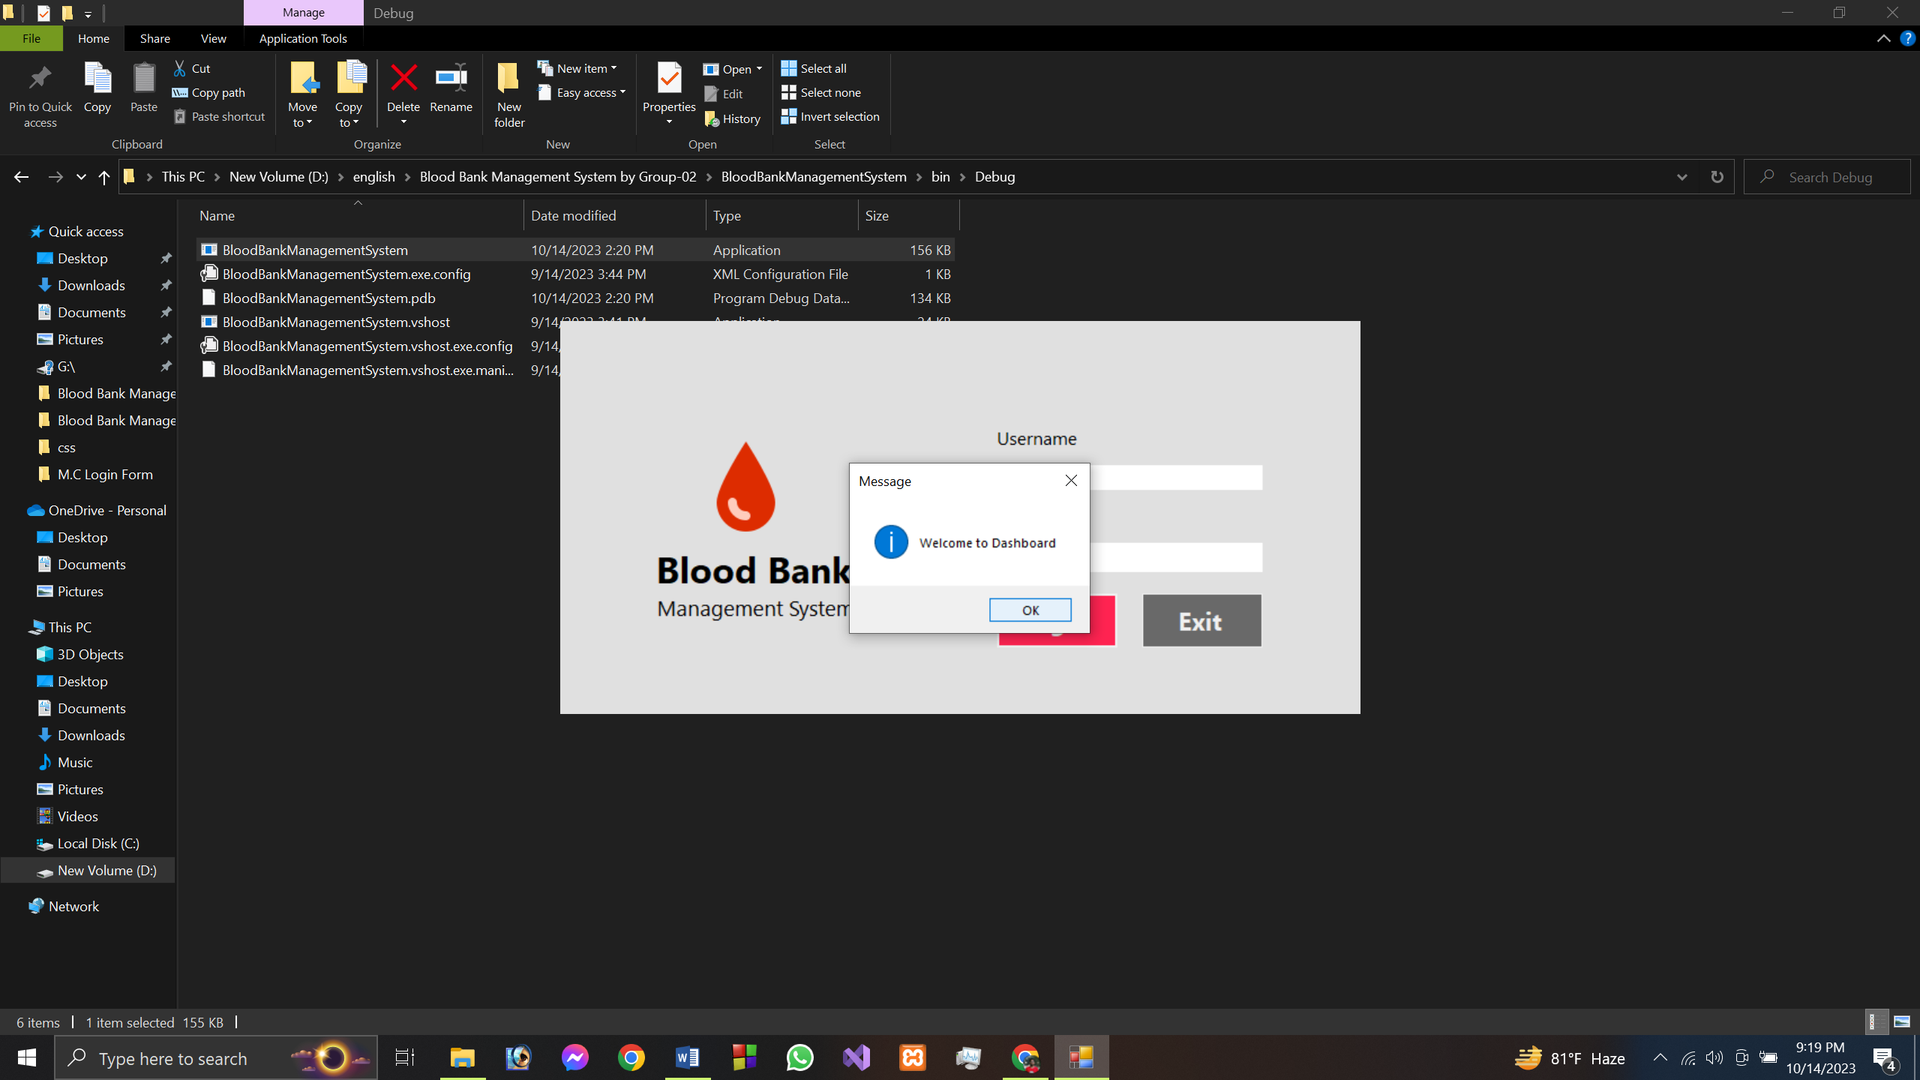

4.wrong password or username shows

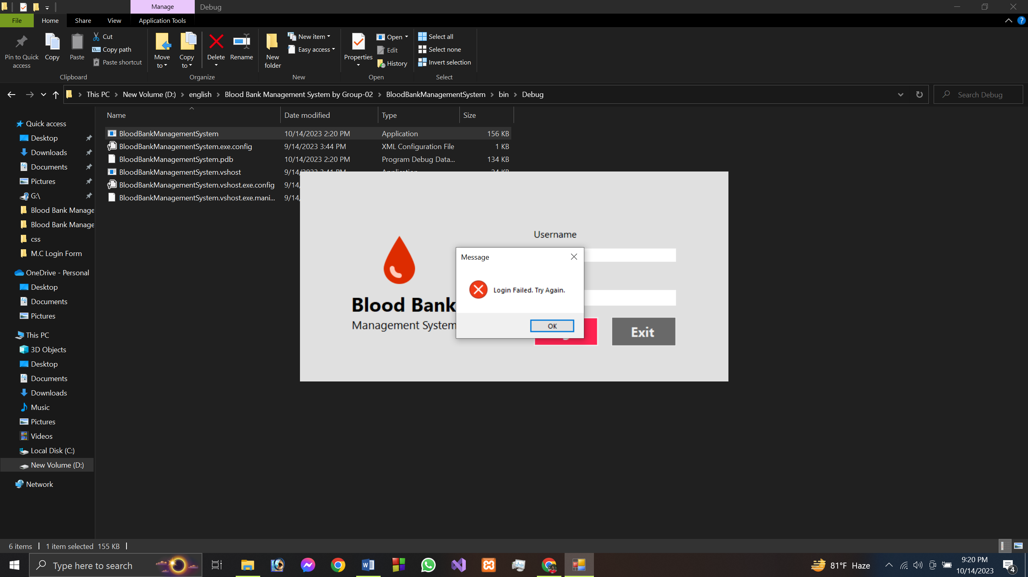

5.Dashboard or Home page

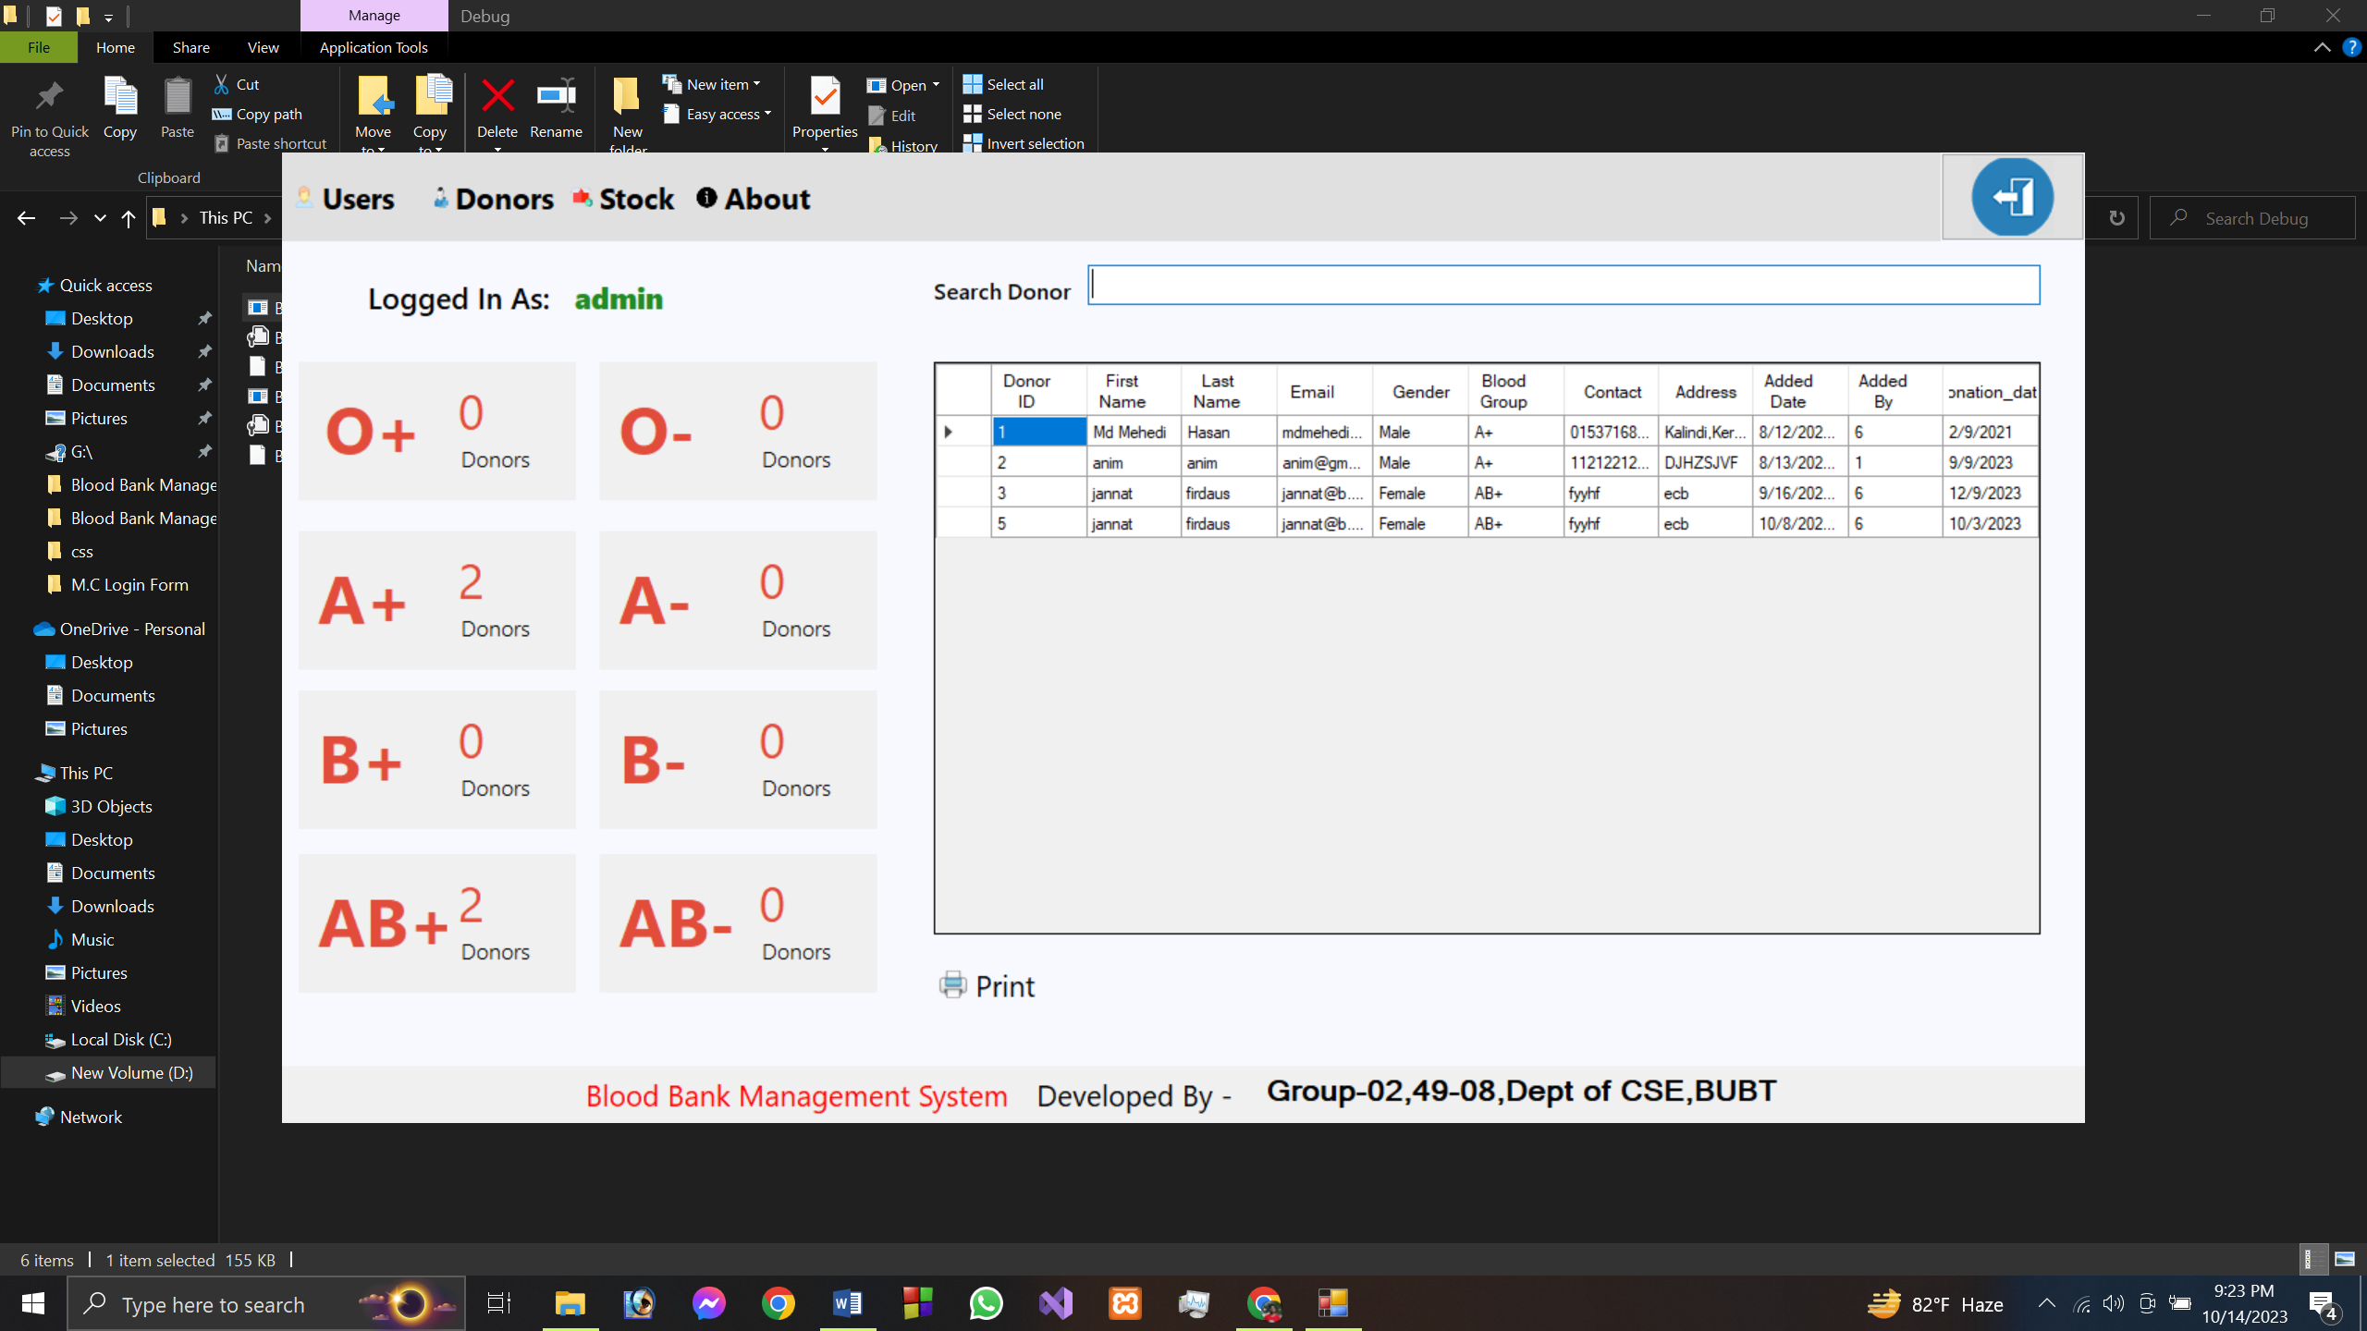

We have 4 menu button they are Users,Donors,Stock,About

Logged in As: here we can see who logged here

Then we have a panel of 8.here we can see the count of every blood group that we have in database.

We have a search option where we can search the donor bases on donor id,blood group,email,contact,first name or last name.

We have a gridview of the donor database so we can see the data of donors.

We have a print button by clicking it we can print out the details of database.

On the corner we have logout option. Clicking it user will be logout from system.

6.clicking on Users will open user form

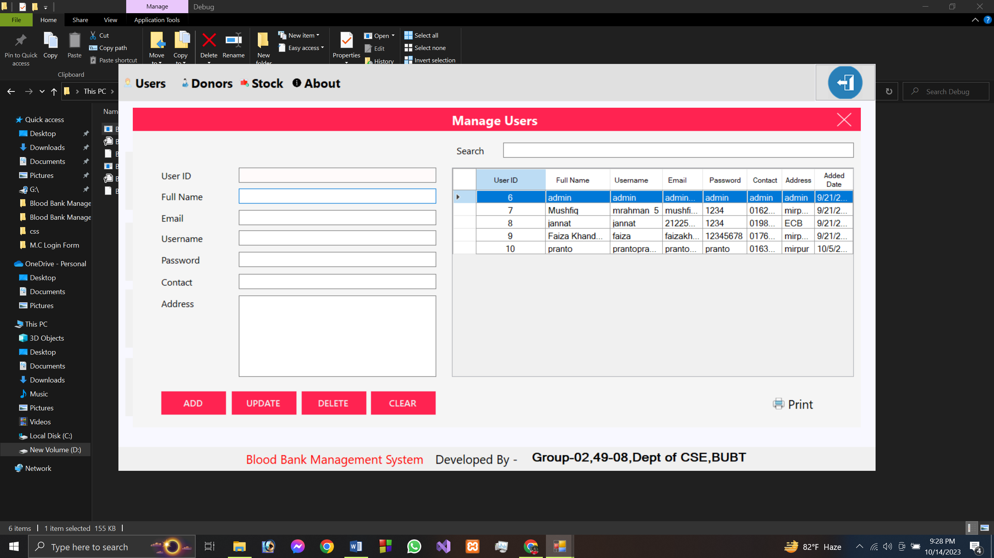

Here in the user form we have 4 buttons.

after filling out the text boxes

ADD button: we can add users/admins to the system.

UPDATE button: we can update/edit the existing user details.

DELETE button: we can delete users from existing user in database.

CLEAR button : If we select a users by mistake o want to cancel any operation we can click it.it will clear the textboxes.

Print button: by clicking it we can print out the details of database.

7. clicking on Donors will open Donors form

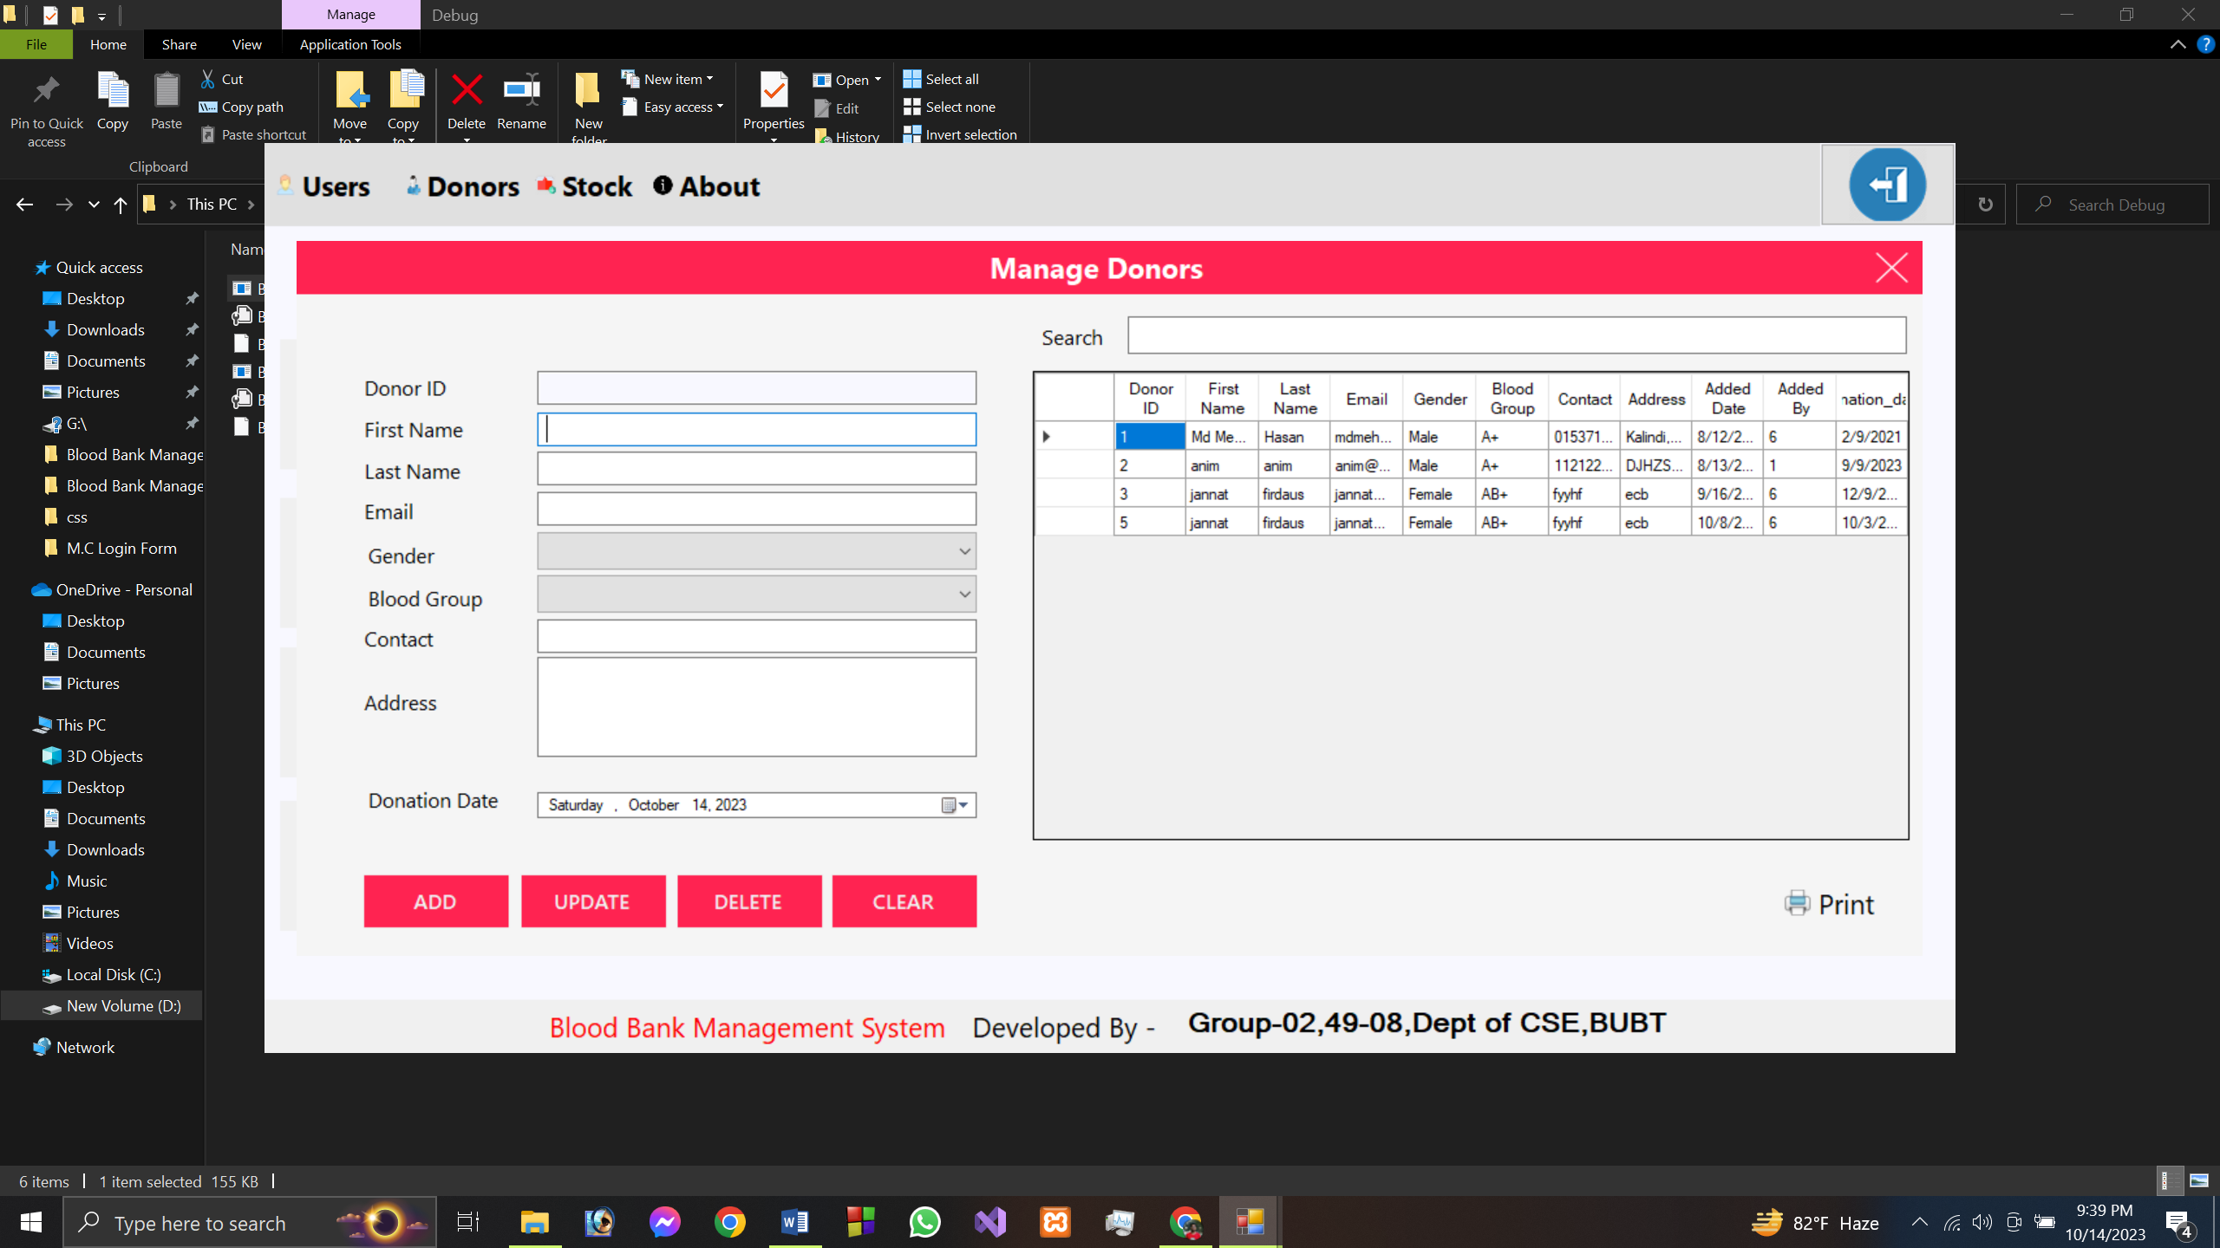

Here in the user form we have 4 buttons.

after filling out the text boxes

ADD button: we can add donors to the system.

UPDATE button: we can update/edit the existing donors details.

DELETE button: we can delete donors from existing donors in database.

CLEAR button : If we select a donors by mistake o want to cancel any operation we can click it.it will clear the textboxes.

Print button: by clicking it we can print out the details of database.

8. clicking on Stock button

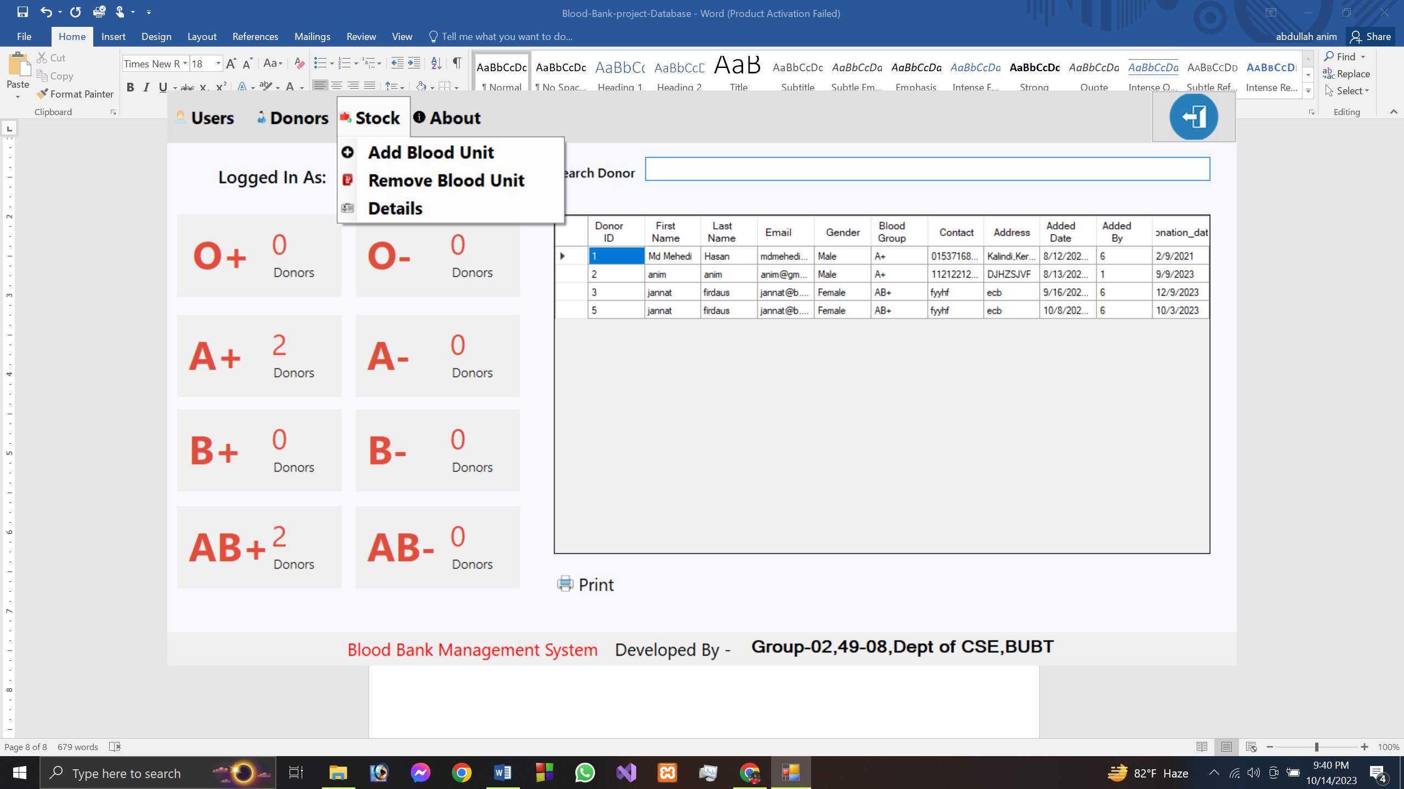

We can see 3 buttons they all do different operations.

Clicking on

Add Blood Unit:

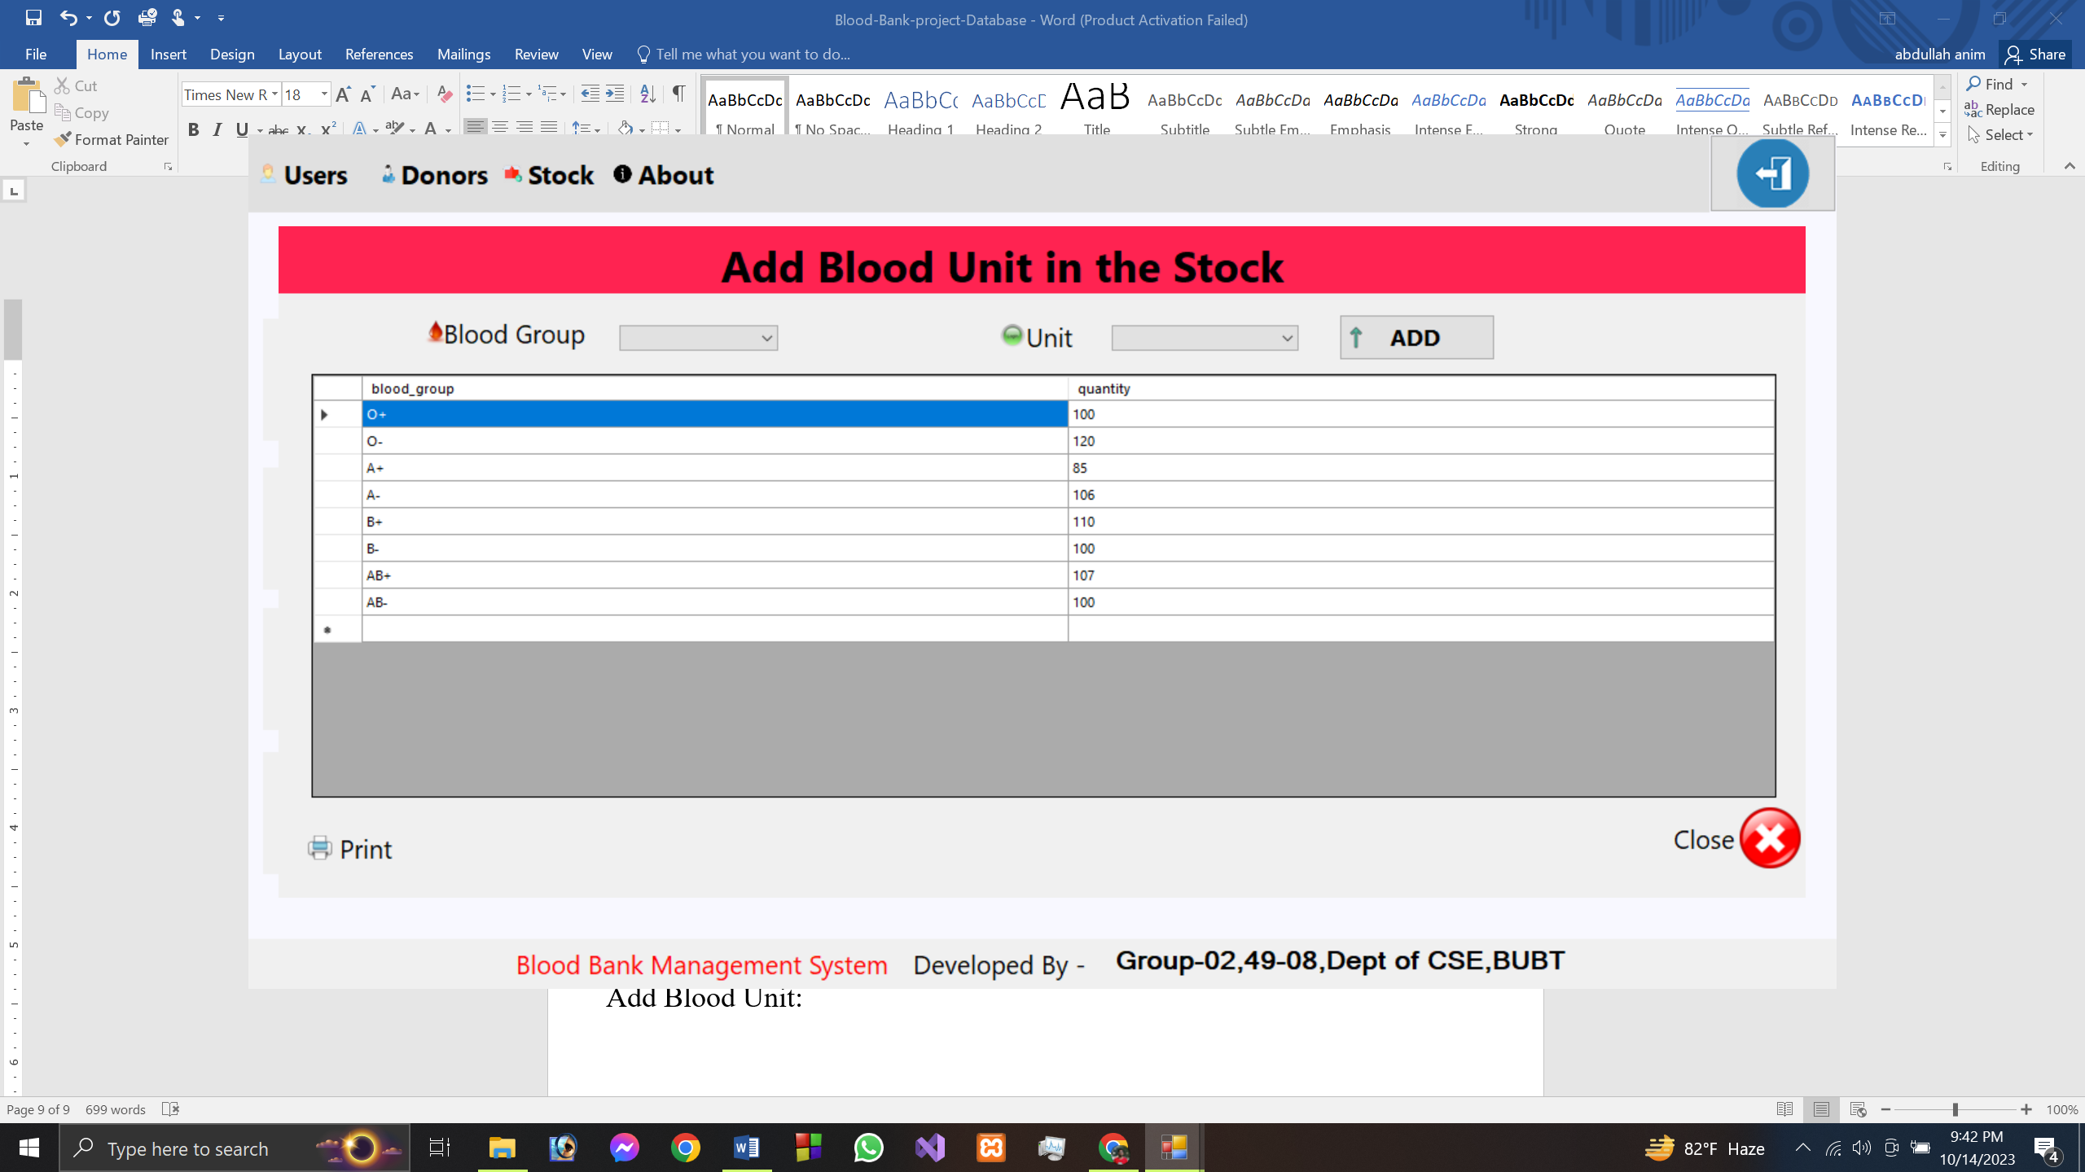

Here we have blood group we can select the specific blood which I want to add in our stock.

In the grid view we can see the blood group and its quantity from stock database.

We have a print button by clicking it we can print out the details of database.

Clicking on

Remove Blood Unit:

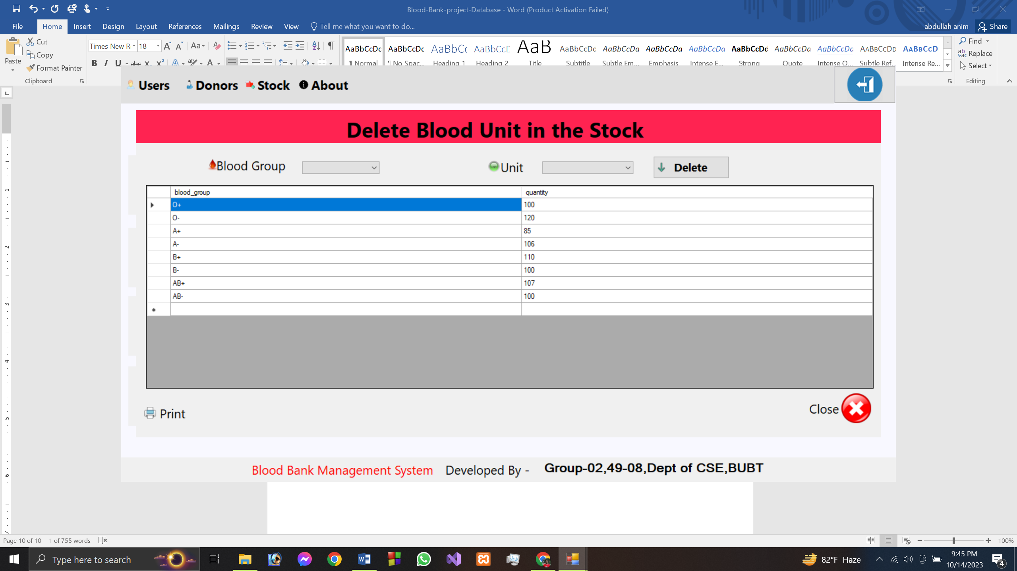

Here we have blood group we can select the specific blood which I want to delete in our stock.

In the grid view we can see the blood group and its quantity from stock database.

We have a print button by clicking it we can print out the details of database.

Clicking on

Details:

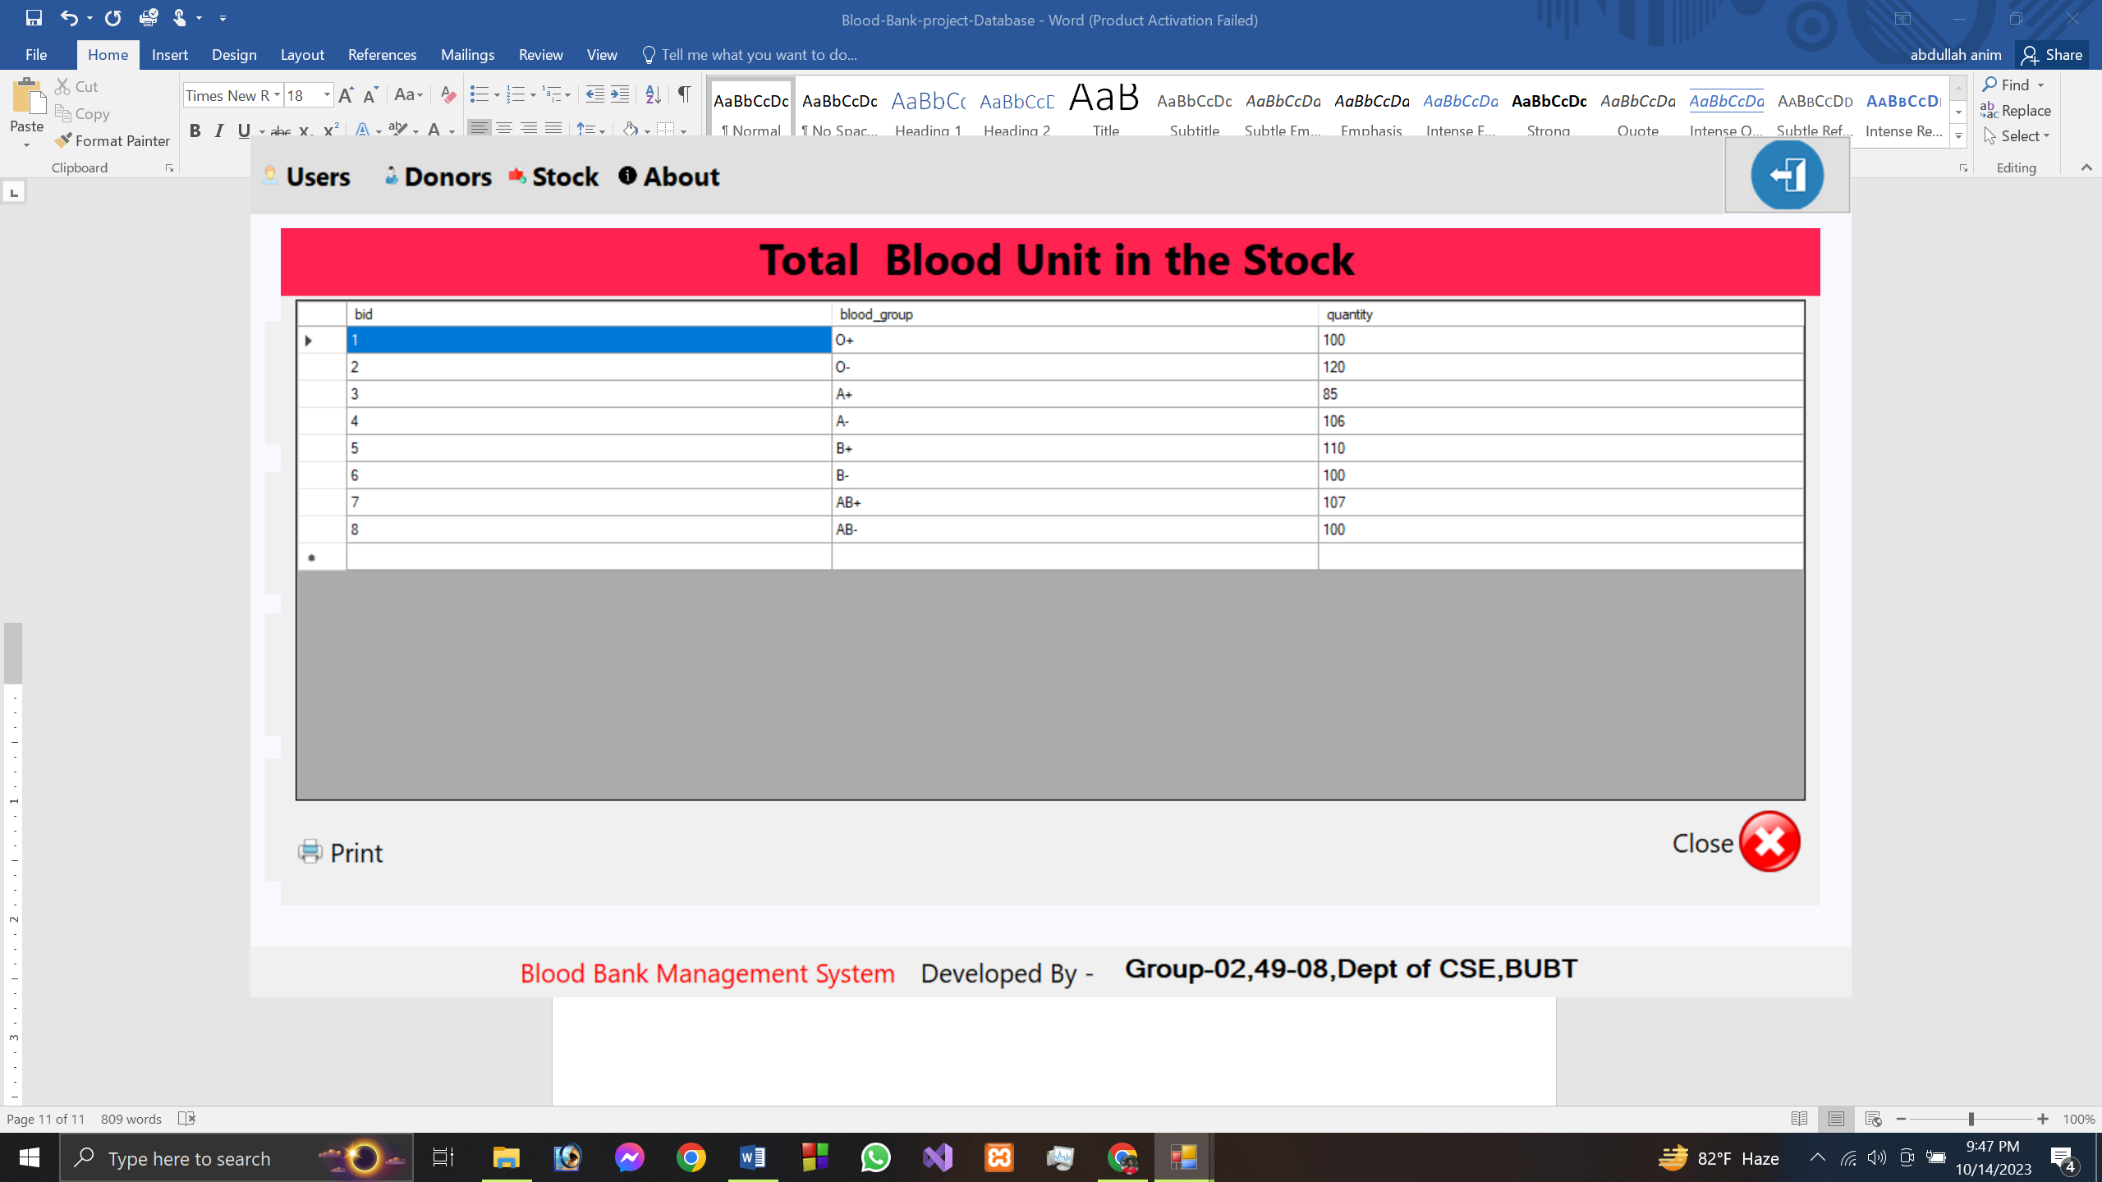

We have a print button by clicking it we can print out the details of database.

In the grid view we can see the blood group and its quantity from stock database.

We don’t have any operations here.

9.clicking on About:

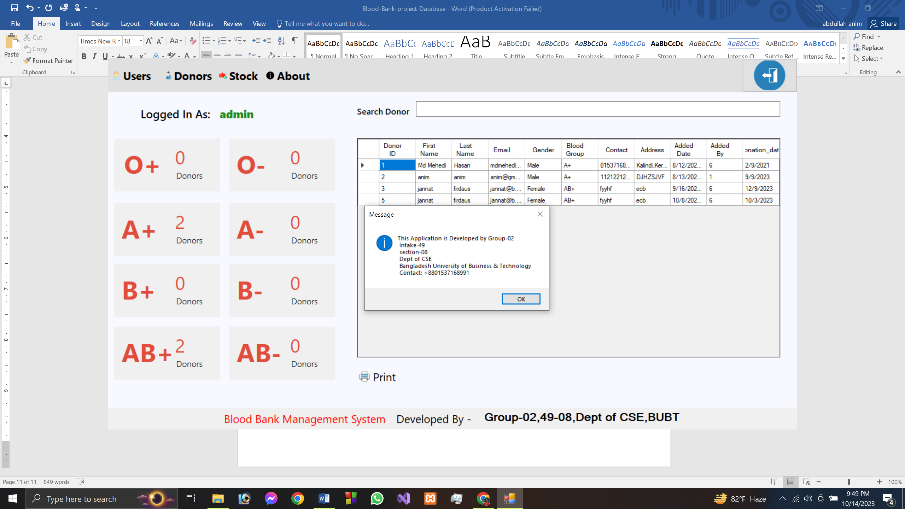

A message will popup where developer details and contact given.

In case of any bugs,or problems they can contact them.